Summary of Tasks Completed

Introduction
The purpose of this midterm was to implement and analyze fundamental cryptographic operations used in modern secure communication systems. The assignment included four major tasks: symmetric encryption with AES, digital signatures using ECC, hashing and HMAC integrity verification, and secure key exchange using Diffie–Hellman. All tasks were executed in a Linux environment using OpenSSL, Python, and Git for version control. This report documents each step, provides validation output, and explains the security relevance of each cryptographic technique.

Tools Used
- Ubuntu Linux — primary environment for executing cryptographic tasks.
- Bash Terminal — command execution, file management, and OpenSSL operations.
- OpenSSL — AES encryption/decryption, ECC key generation, and signature verification.
- Python 3 — hashing, HMAC, and Diffie–Hellman simulation.
- hashlib module — SHA-256 hashing.
- hmac module — HMAC-SHA256 computation.
- secrets module — cryptographically secure private key generation.
- Nano Editor — script and file editing.
- Git — version control, documentation, and reproducibility.
- GitHub — remote repository hosting for final submission.

Github submission page - https://github.com/IA-art-commits/Week5_Midterm.git

1. Project Environment Preparation
A dedicated working directory was created in the Linux environment to contain all midterm-related files. Git version control was initialized to track changes, maintain proper documentation, and support reproducibility of the work.
Commands executed:
mkdir week5-midterm
cd week5-midterm
git init

2. Git Author Identity Configuration
Git required a valid username and email address to sign commits. When attempting the first commit, Git issued an “Author identity unknown” warning.
To correctly associate commits with the student’s identity, the following global configuration was applied:
git config --global user.name "IA BEROSHVILI"
git config --global user.email "iaberoshviliz@gmail.com"
Verification:
git config --global --list
This ensured proper commit attribution, linked the work to the correct GitHub account, and enabled professional repository tracking.

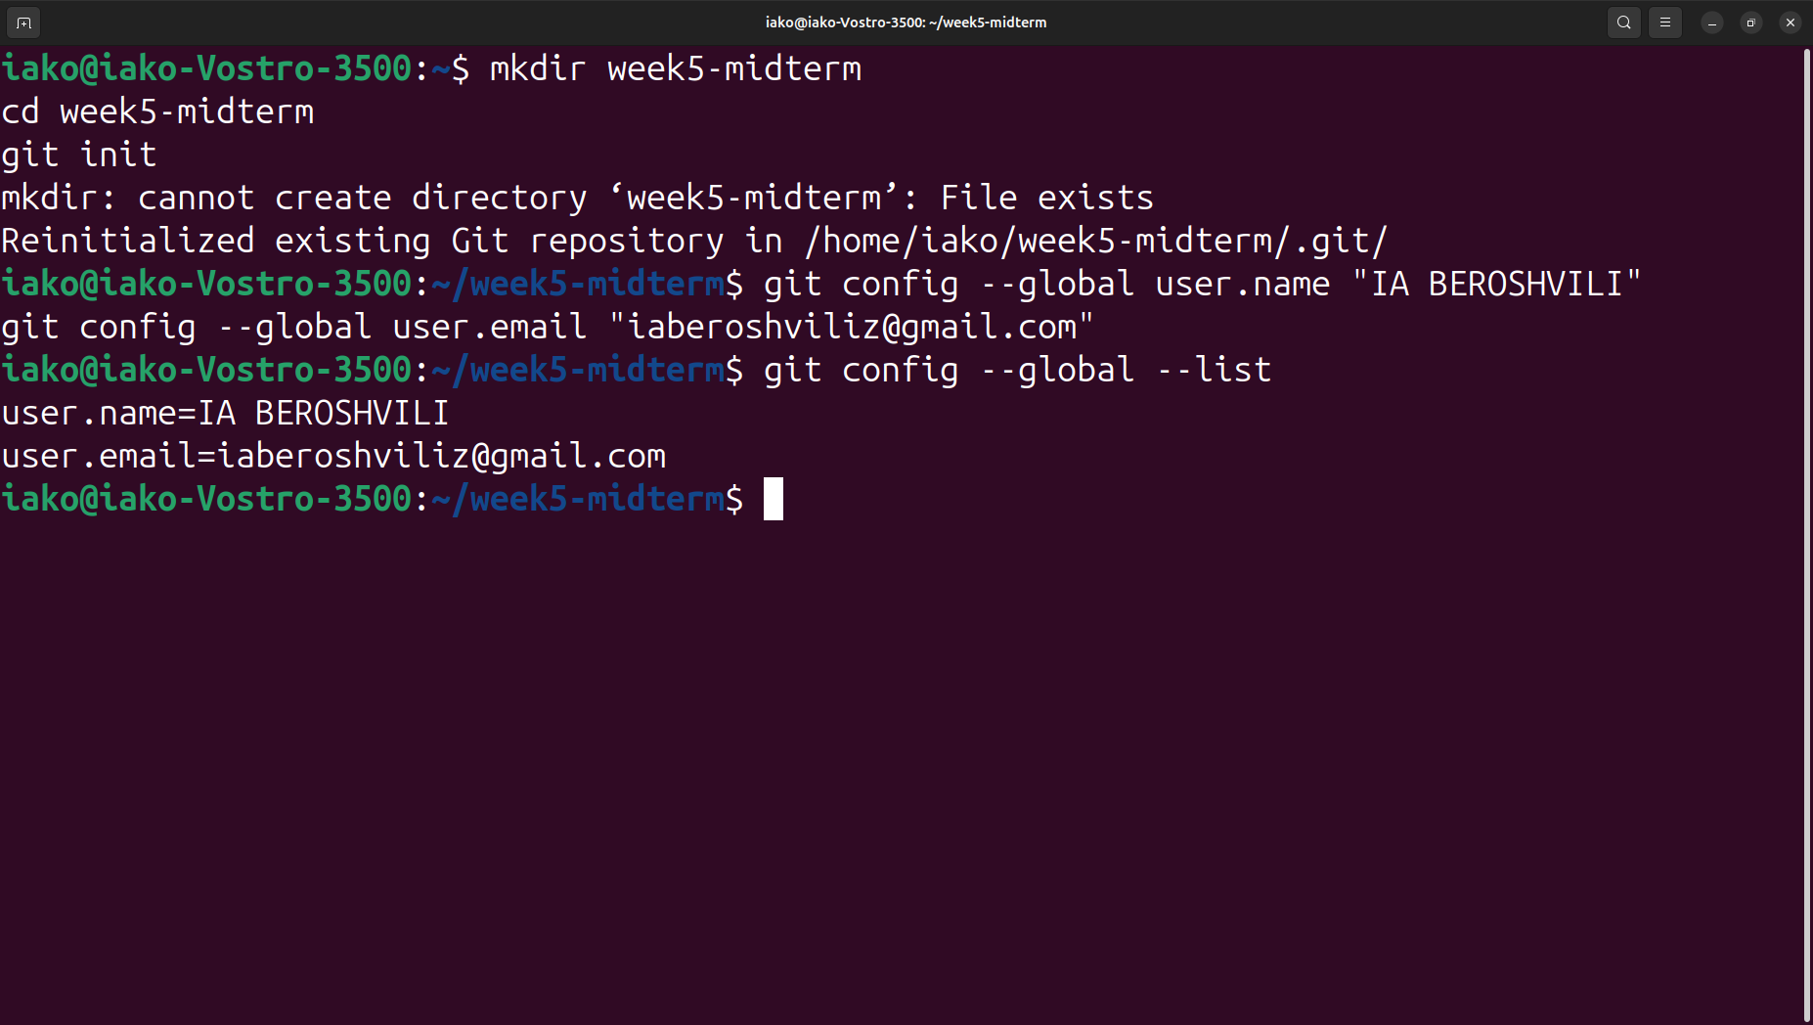

3. AES File Encryption and Decryption (Task 1)

A text file (secret.txt) containing sensitive information was created and securely encrypted using AES-128-CBC with OpenSSL. The encryption process included the use of a salt and PBKDF2 to ensure modern cryptographic security.
Encryption:
openssl enc -aes-128-cbc -salt -pbkdf2 -in secret.txt -out secret.enc
Decryption:
openssl enc -d -aes-128-cbc -salt -pbkdf2 -in secret.enc -out secret_decrypted.txt
Integrity verification was performed using:
diff secret.txt secret_decrypted.txt
The decrypted file fully matched the original, demonstrating correct encryption and recovery.
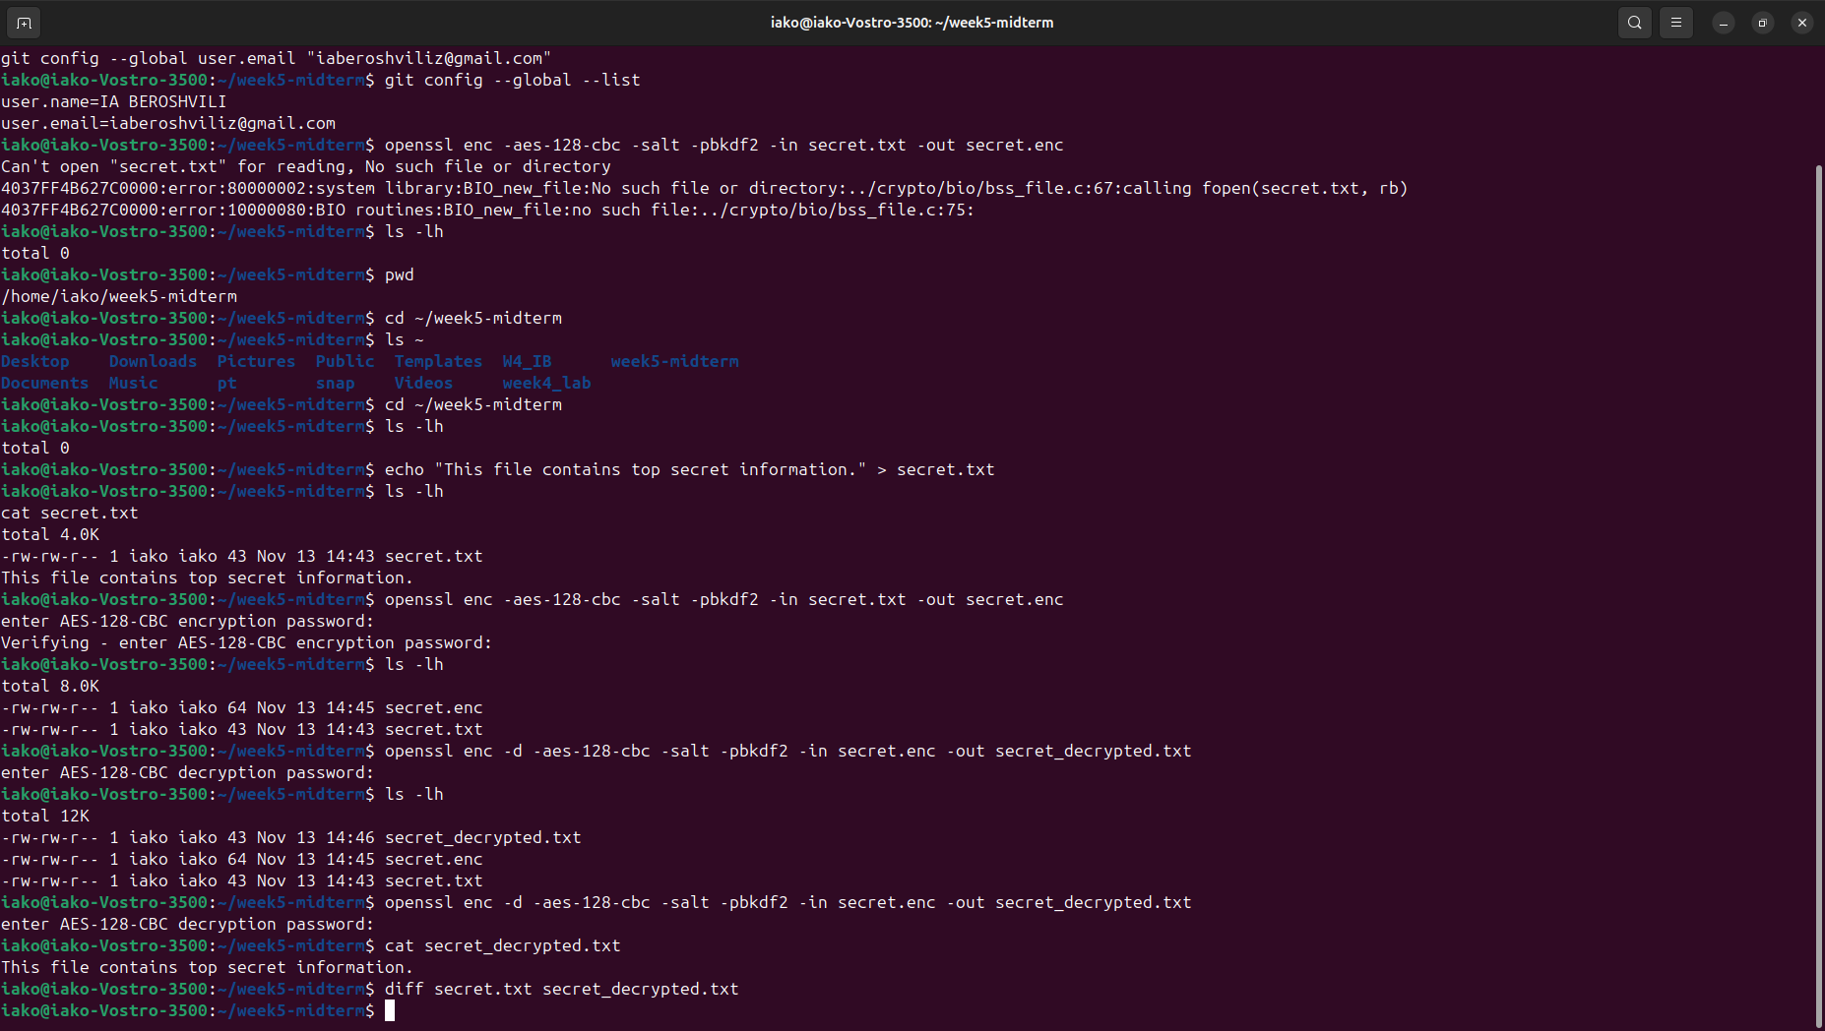

4. ECC Key Pair Generation and Digital Signature (Task 2)
An Elliptic Curve Digital Signature Algorithm (ECDSA) workflow was implemented using prime256v1, one of the most widely used and secure curves.
Key generation:
openssl ecparam -name prime256v1 -genkey -noout -out ecc_private_key.pem
openssl ec -in ecc_private_key.pem -pubout -out ecc_public_key.pem
A message (ecc.txt) was signed with the private key:
openssl dgst -sha256 -sign ecc_private_key.pem -out ecc.sig ecc.txt
Signature verification with the public key produced:
Verified OK
This demonstrated authenticity, integrity, and proper use of ECC cryptography.

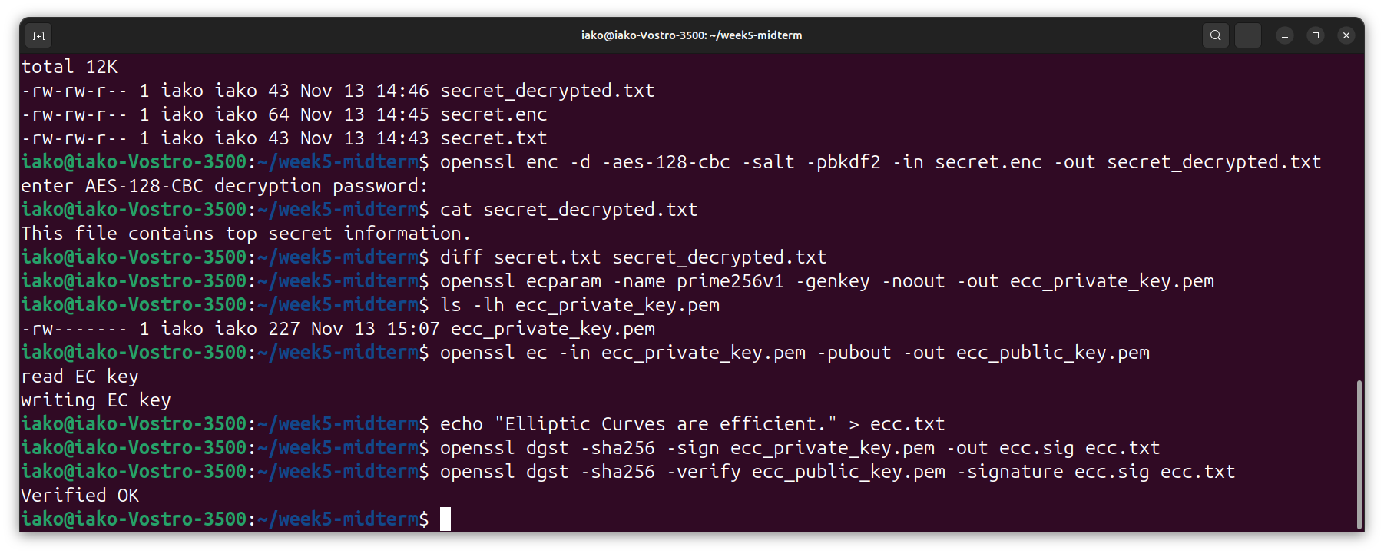

5. SHA-256 Hashing and HMAC Generation (Task 3)
A Python script (hash_hmac.py) was created to compute a SHA-256 hash and an HMAC-SHA256 for a given message (data.txt).
The script:
- Reads the file
- Computes its SHA-256 hash
- Computes HMAC with a shared secret key
- Prints both outputs
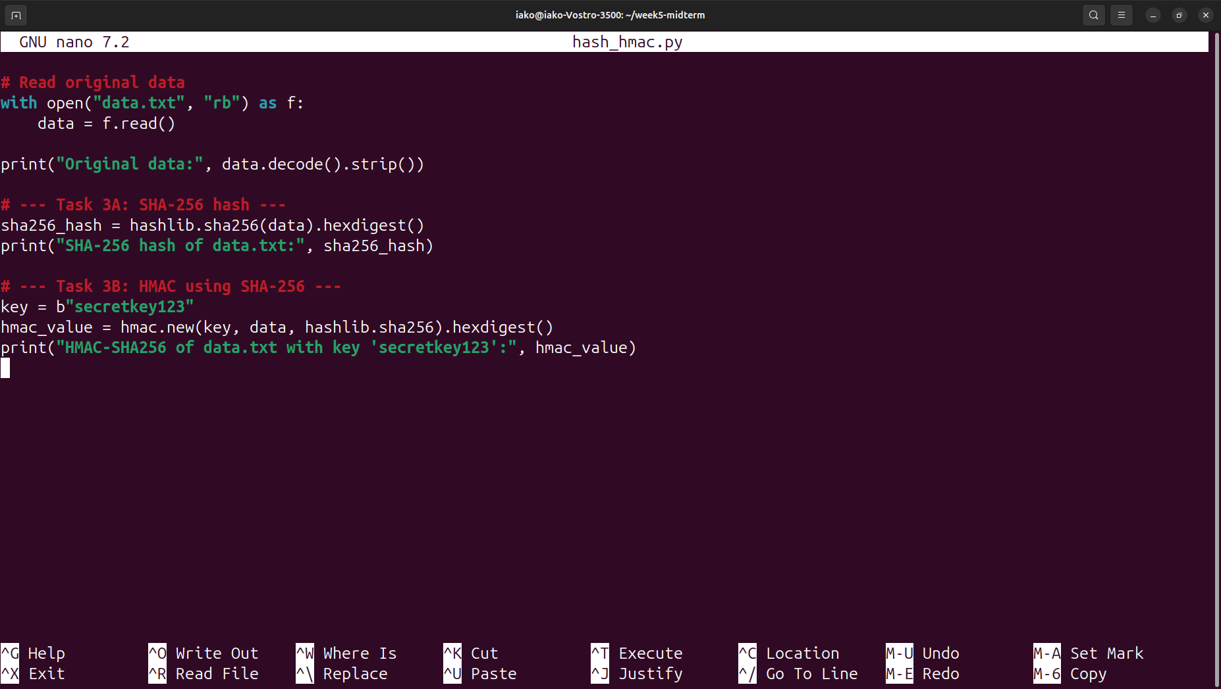

Execution: python3 hash_hmac.py

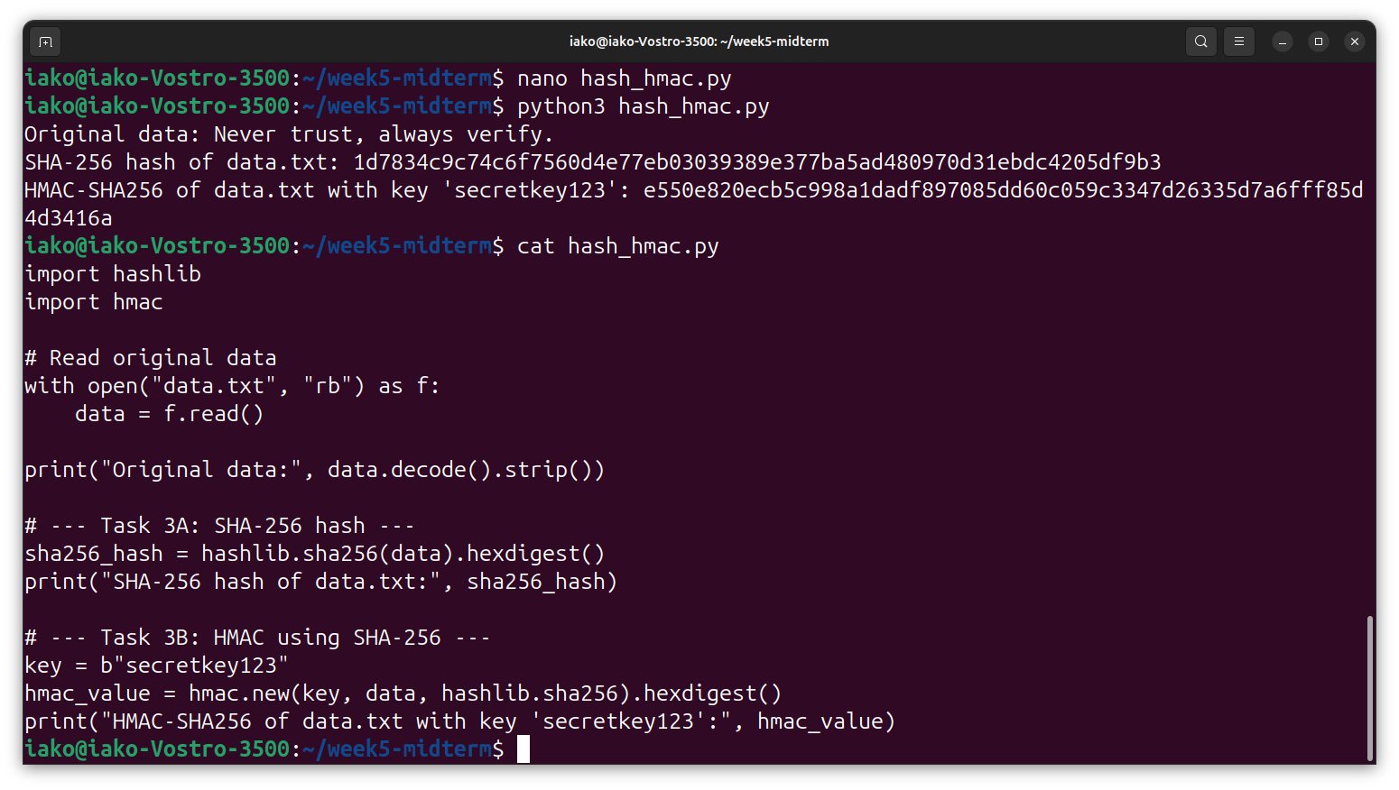
For the integrity test, the content of the file was intentionally altered. Re-running the script produced completely different hash and HMAC values, demonstrating:
- the avalanche effect
- the ability of HMAC to detect even minor modifications
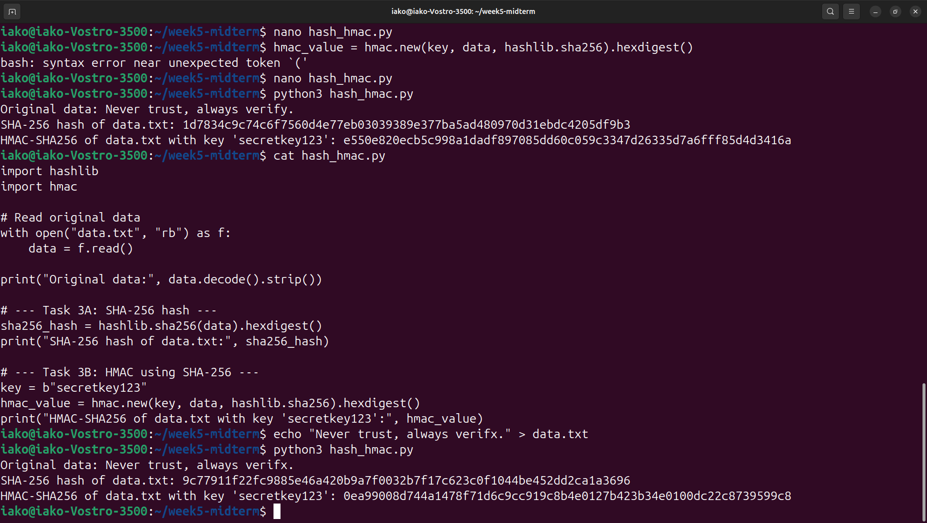

Integrity Verification and Avalanche Effect Demonstration
To evaluate the integrity protection provided by hashing and HMAC, the original file data.txt was deliberately modified by changing a single character:
Original:
Never trust, always verify.
Modified:
Never trust, always verifx.
After modifying the file, the Python script was executed again, producing the following new values:
- New SHA-256 hash:
9c77911f22fc9885e46a420b9a7f0032b7f17c623c0f1044be452dd2ca1a3696
- New HMAC-SHA256 (key = "secretkey123"):
0ea99008d744a1478f71d6c9cc919c8b4e0127b423b34e0100dc22c8739599c8
These values are completely different from the original hash and HMAC:
- Original SHA-256:
1d7834c9c74c6f7560d4e77eb03039389e377ba5ad480970d31ebdc4205df9b3
- Original HMAC-SHA256:
e550e820ecb5c998a1dadf897085dd60c059c3347d26335d7a6fff85d4d3416a
The drastic change in outputs demonstrates the avalanche effect, where even a one-character modification results in an entirely different hash and message authentication code.
This confirms:
- Integrity — the hash detects any alteration to the data.
- Authenticity — the HMAC ensures only someone with the secret key can produce a valid code.
- Tamper detection — any unauthorized modification is immediately identifiable.
This experiment clearly shows that SHA-256 and HMAC-SHA256 provide strong integrity and authenticity guarantees.

6. Diffie–Hellman Key Exchange Simulation (Task 4)
A Python script (dh_simulation.py) was written to simulate a Diffie-Hellman (DH) key exchange between Alice and Bob using shared public parameters ( p ) and ( g ).
The program:
- Generates private keys for Alice and Bob
- Computes public values
- Derives a shared secret on both sides
- Verifies that the shared secrets match

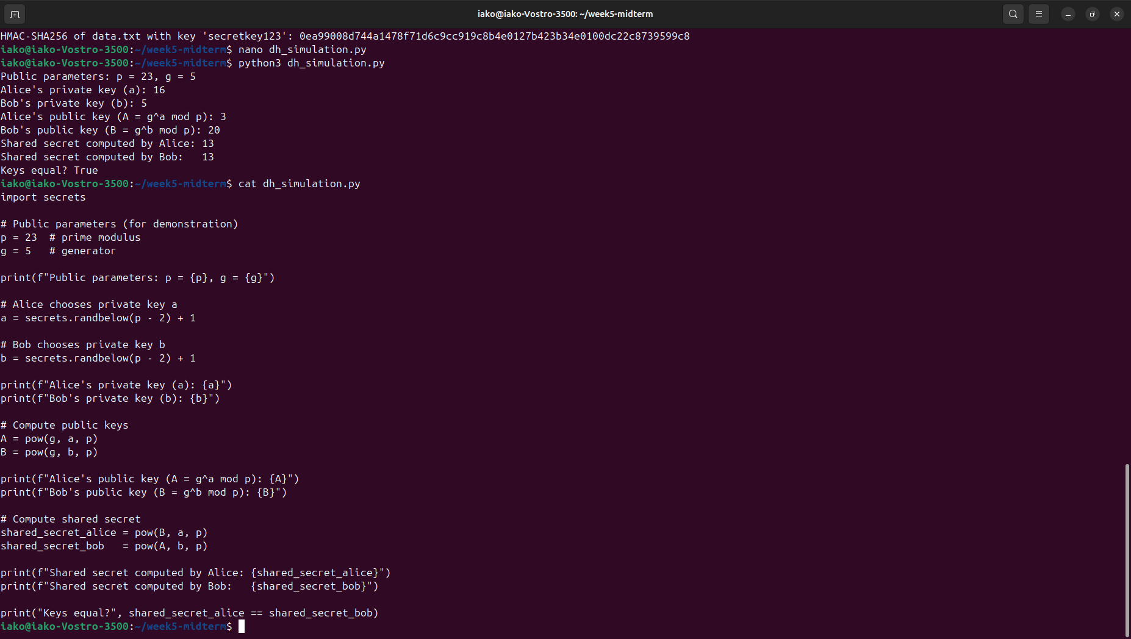
This demonstrates how DH securely establishes a shared symmetric key over an insecure channel.

Diffie–Hellman Key Exchange Simulation (with actual results)
In this task, a Python script (dh_simulation.py) was implemented to simulate the Diffie–Hellman key exchange between two parties, Alice and Bob. The goal was to demonstrate how both participants can derive the same shared secret over an insecure channel without explicitly transmitting the secret itself.
The script output confirmed:
Shared secret computed by Alice: 13
Shared secret computed by Bob: 13
Keys equal? True
Since both parties independently derived the same shared value (13), this demonstrates that the Diffie–Hellman algorithm correctly established a common secret key without ever sending that key directly over the communication channel.

7. Documentation and Version Control
All outputs, test results, screenshots, and scripts were added to Git and prepared for upload to GitHub:
git add .
git commit -m "Week 5 midterm completed"
This ensured full reproducibility and traceability of all steps performed in the assignment.

Conclusion
In Task 1, AES-128-CBC encryption and decryption illustrated the principles of symmetric encryption and the importance of secure key usage through password-based key derivation (PBKDF2). Task 2 showed how elliptic curve cryptography (ECC) provides efficient and strong digital signatures, enabling message integrity and authenticity using asymmetric key pairs. Task 3 offered a deeper understanding of cryptographic hashing and HMAC generation, demonstrating the avalanche effect and how keyed hashing protects against tampering. If an attacker modifies the data but does not know the key, they cannot create a matching HMAC. This means the modified message will be immediately rejected. Task 4 simulated the Diffie–Hellman key exchange, proving how two parties can establish a shared secret over an insecure channel without transmitting the secret itself.
Diffie–Hellman is widely used in real-world secure communication systems to safely establish shared encryption keys. In the TLS handshake (which secures HTTPS websites), browsers and servers use Diffie–Hellman or Elliptic Curve Diffie–Hellman (ECDHE) to create a temporary session key that encrypts all web traffic. In secure messaging apps like Signal, the protocol uses multiple Diffie–Hellman operations (X3DH and the Double Ratchet algorithm) to exchange keys and continuously refresh them, ensuring forward secrecy. Diffie–Hellman is essential in modern secure communication because it enables two parties to establish a shared encryption key without transmitting the key itself. This prevents attackers from learning the key even if they intercept all traffic. The shared key supports confidentiality, integrity, forward secrecy, and protection against man-in-the-middle attacks when combined with authentication mechanisms. The successful verification that both computed keys are identical confirms that the secure key exchange was performed correctly.
Across all tasks, version control with Git ensured full reproducibility, accountability, and professional documentation of the work.
Overall, this midterm not only reinforced theoretical cryptographic concepts but also provided practical skills directly applicable to secure communications, digital identity, and modern cybersecurity systems. The experiments highlight how cryptographic primitives form the foundation for real-world security protocols used in web security (TLS), authentication systems, secure messaging applications, and key-exchange mechanisms. These exercises deepen understanding and strengthen readiness for advanced applied cryptography and cybersecurity challenges.

